*Insula*

*Tokenomics*

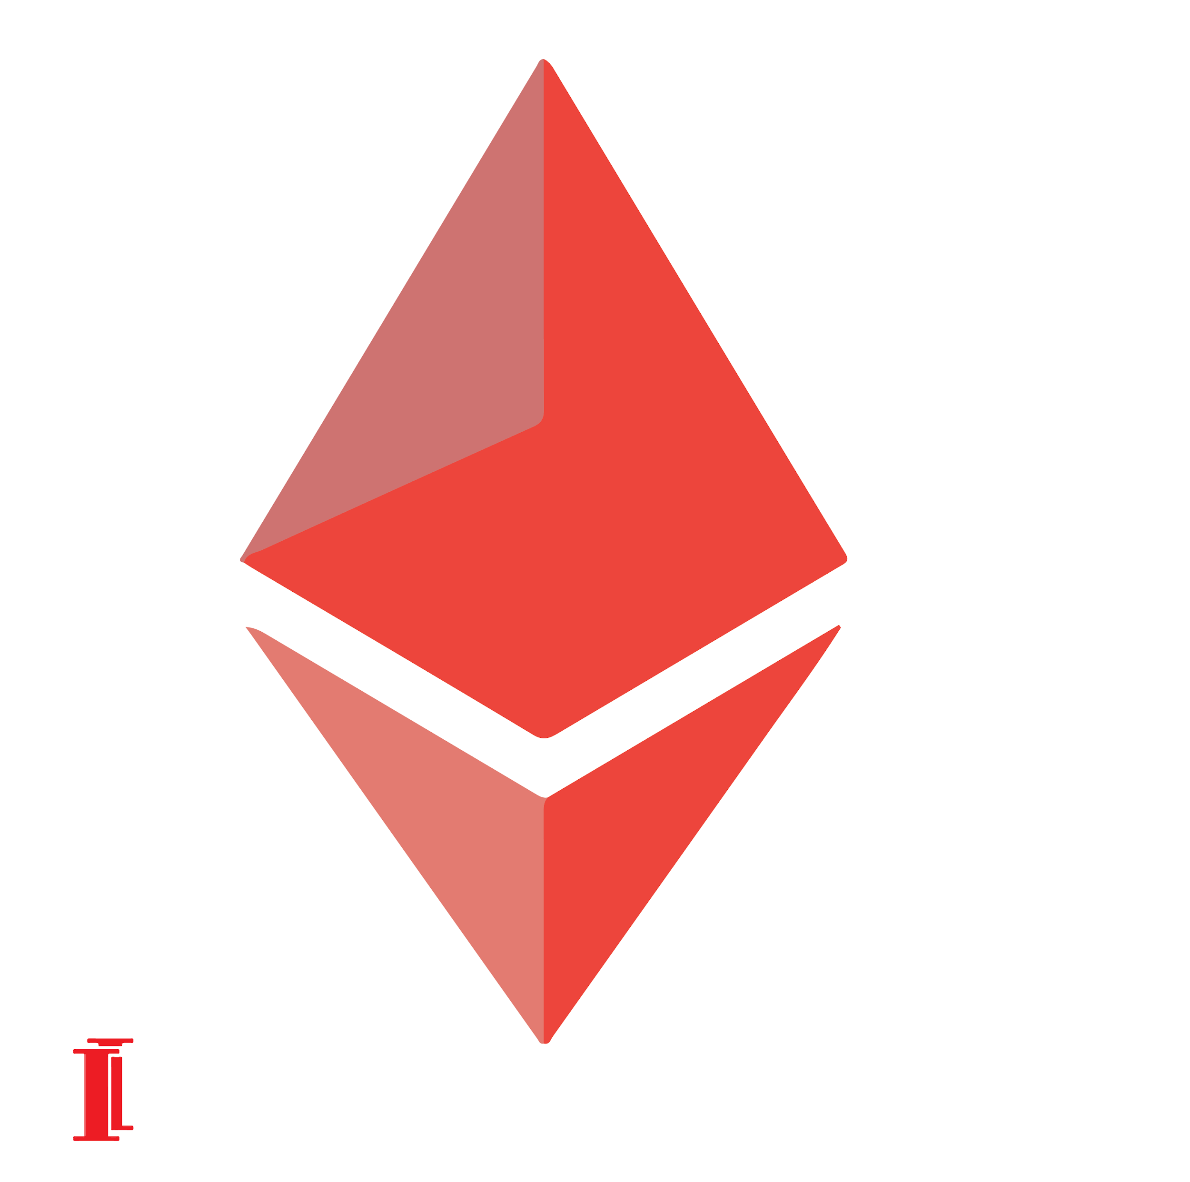

**What is Insula?**

Insula, or Insula Investment management, is a cryptocurrency asset manager for advanced crypto investors. We provide freemium SaaS, and operate blockchain-based investment funds that allow investors to maintain control over their crypto assets, in a cyber secure environment without any counterparty risk.

**What is ISLA?**

Insula built its proprietary payment ecosystem.

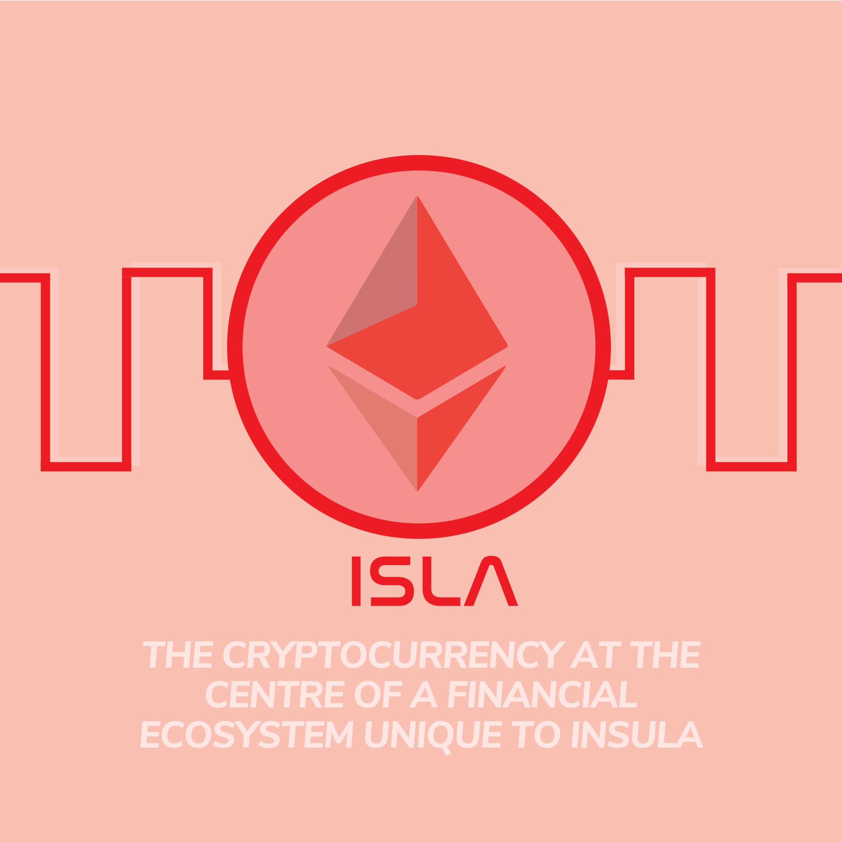

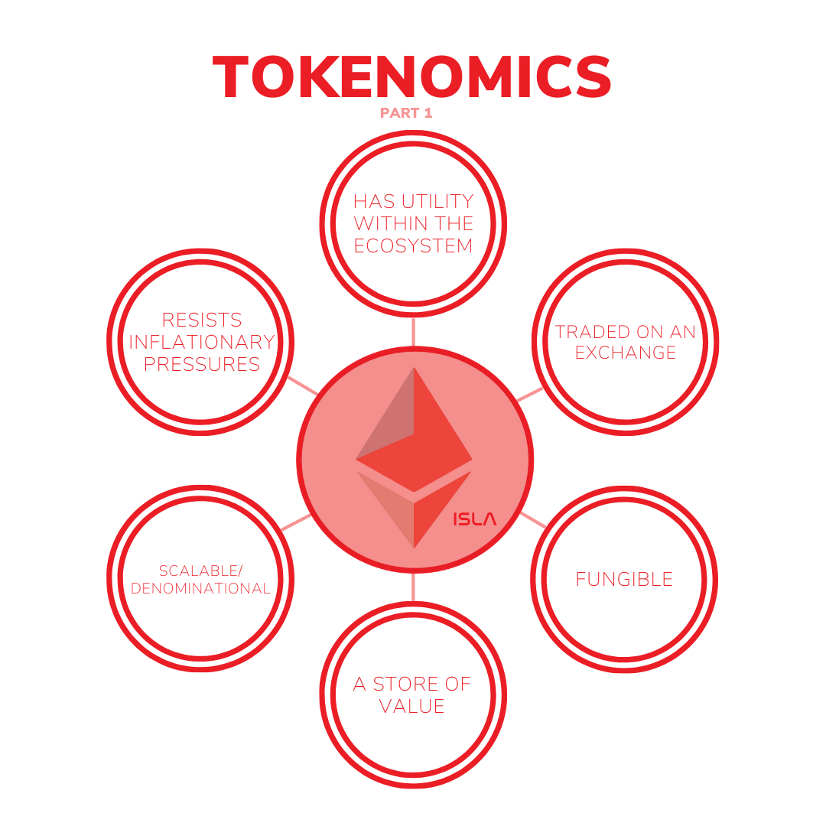

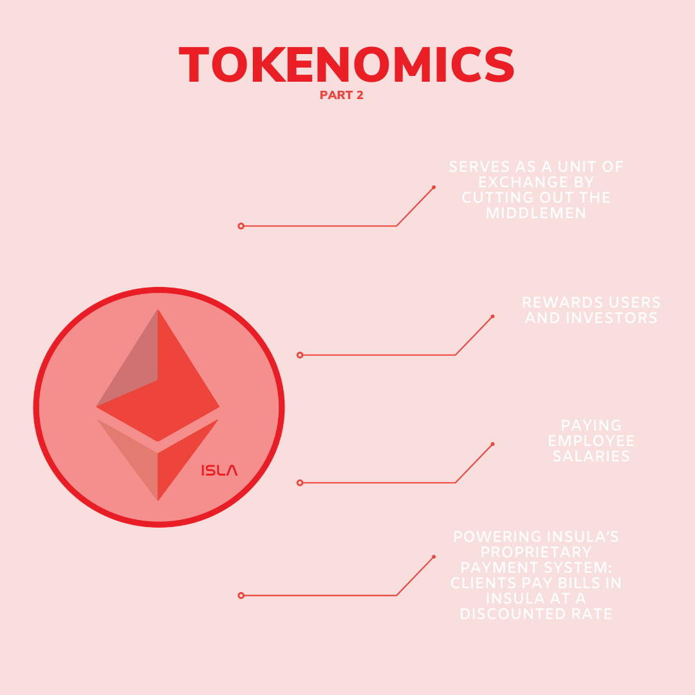

##### 

##### 

##### 

##### *ISLA is the cryptocurrency that incentivizes our fully decentralized network*

*Insula Token is an ERC20 Token, which means it is ran by a smart contract on the Ethereum Blockchain*

***Insula’s Smart Contract***

*for token generation acts as a trusted bookkeeper*

*would normally support such beliefs by keeping a central record of how many units of an asset have been issued and who holds them at any point in time.*

###### **Insula Token (ISLA) owners can:**

###### 

###### Pay bills to Insula Investment Management in ISLA.

###### Stake ISLA and receive interests.

###### Sell ISLA against 100+ other cryptocurrencies.

###### Hold ISLA as a long term investment.

**The Insula token takes care of the following:**

###### Serves as a unit of exchange by cutting out the middlemen.

###### Rewards users and investors.

###### Pays employees’ salaries.

###### Powers Insula’s proprietary payment system.

*About ISLA:*

282 unique holders

652 transfers

1k smart contract calls

#### Total fixed supply 1,049,675.602077199999701949 ISLA

Non inflationary supply

​Predetermined & exact maximal finite supply​

Tamper-proof & forever immutable timestamping

Capital Withdrawable At Anytime

Management & Custodial Fee 0%

Defi Liquidity

Trading on 5+ Decentralized Exchanges on 100+ ETH Tokens

Custodian Ethereum Blockchain

Current Development Status: in Full Function

Total Trading Volume: 3.25M+ Insula Tokens moved on-chain

Ethereum proof of work mining process

Designed to be ASIC-resistant via memory-hardness and easily verifiable

Auditors: Insula's Blockchain ledger. Human readable via Etherscan

Token type: ERC20 Standards compliant